**Group 7**

Kenneth Dong

Mei Huang

Shanelle Khan

Bomy Rhee

RPIdorms

**March 17, 2022**

# Overview

There are four stages that we have outlined for our term project: initiation, planning, execution, and review. The initiation phase incorporates our goals and the general scope of our project. The planning phase will introduce each of our team member’s tasks and role in the group. The execution phase is where we will outline the timeline and general schedule of how this project will work out until its deadline. The final phase is our presentation of our term project with a working prototype.

# Initiation

## Goals

1. **Help students, specifically freshmen:** We want to better assist freshmen that are transitioning from high school to college and make it as stress-free as possible by providing them all the necessary information to adjust.
2. **Share insight of RPI student life:** As students at RPI, we want to share our experiences and knowledge about the school through this platform. We believe our platform could serve as an essential resource for incoming students.

## Scope

1. Measuring success:

A successful outcome would result in a website that is functional with architecture that is convenient to the user. Each webpage should resemble similar layouts with other pages to make a uniformed product.

1. Project:

In this project, we would like to create a functional final product that upholds our standards. In order to do this, we will communicate regularly, brainstorm ideas together, and each give effort to polish the product in order to get the success that we are looking for. Once finished, we will gain experience on working with multiple languages, dealing with both front and back end design, and seeing how it all unifies to a singular website.

1. Possible boundaries

Some boundaries as we work towards our final product might include time. There are always improvements that can be made and it's important to know when to stop working in a particular section in order to develop a different section given a limited time frame.

## Milestones

## Create Website I/A

* Make a basic HTML and CSS design that can be reusable on multiple pages.
* Create a javascript file and plan out what needs functionality. List how to make a basic implementation of that functionality.

## Take Pictures of All The Dorms

* In order to do this faster, ask others for dorm room photos.
* Try to keep the photos relatively similar from one dorm to another (good quality)

## Add the photos to the website

* Create a new button for the dorms page
* Add the photos to the page
* Other formatting

## Discuss improvements/ Make those changes / Keep adding to website

* Talk about how the product can be improved.
* Finish project by separating roles on any sections not finished

1. Submit final product

# Planning

## Roles

Each member of our team holds a crucial role outlined below:

**Kenneth**

HTML/CSS/JS/Dorm Photos

**Mei**

HTML and JS code for dorm pages

**Shanelle**

HTML/CSS/JS/Dorm room photos

**Bomy**

Created header and footer for the general layout of each page (HTML/CSS).

Fixed minor issues with css files.

Developed IA and general outline of project plan.

Created maps page (HTML/CSS/JS)

## Risks

* Keeping the website running and maintained.
  + Could potentially be a financial burden
  + Can be resolved by creating an ad space for RPI related advertisements

## Information Architecture

Our IA can be best viewed through this public link: [octopus.do/wau4007fvi](http://octopus.do/wau4007fvi).

# Execution

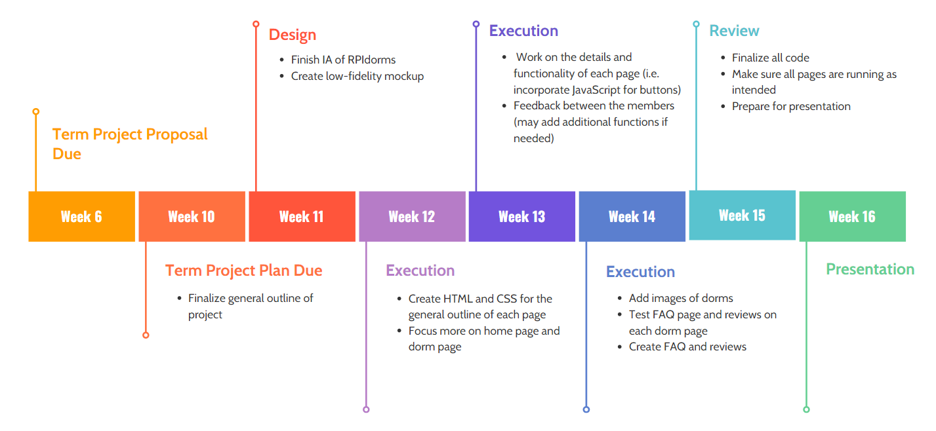

# Review

Our presentation can be found in the *Resources* folder.